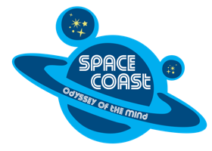
Florida Odyssey of the Mind Association
Space Coast Regional Tournament
2020-2021 Online Team Registration Form
- THIS FORM STAYS WITH THE COORDINATOR/COACH
- Register teams by December 13th at https://www.odysseyofthemind.com/member-area/
- PLEASE NOTE: Team info can be edited UNTIL the payment button is clicked. After that you will NOT be able to change coach information or Add team members.
- Please provide the Coaches Actual Information – NOT the school or coordinator address or phone number.
Membership Number: _____________
Long Term Problem: _____________________________________________________________ Division: __________
Coach #1 Name: _____________________________________________ Email Address: ___________________________________________________
Cell Phone: _____________________
Home Address: __________________________________________________________________
City: _______________________________________ Zip: ______________
CONFLICTS: _____________________________________________________________________________________________________________
_________________________________________________________________________________________________________________
Coach #2 Name: _____________________________________________ Email Address: ___________________________________________________
Cell Phone: _____________________
Home Address: __________________________________________________________________
City: _______________________________________ Zip: ______________
CONFLICTS: _____________________________________________________________________________________________________________
_________________________________________________________________________________________________________________

TEAM MEMBER NAME | GRADE | SCHOOL IF DIFFERENT | PARENTS EMPLOYERS | OTHER INFO; disabilities, special needs, medical info
1.
2.
3.
4.
5.
6.
7.

CONFLICTS: See handbook for examples.
TEAM MEMBER NAME | SCHOOL IF DIFFERENT | CONFLICT | IF SIBLING – SCHOOL, PROBLEM, DIV.

Please note the restrictions regarding adding team members and grade restrictions for division in the
Odyssey of the Mind Program Guide. ANY CHANGES AFTER ENTERED IN THE SYSETEM NOTIFY REGIONAL DIRECTOR

