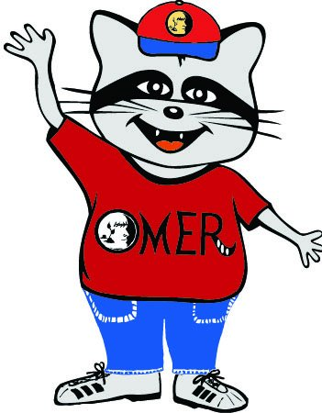
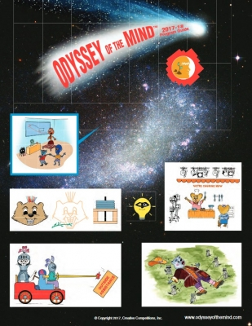
Omer is looking for creative students to join him on problem solving adventures.

Are you creative?
Do you like to act?
Do you like to build things?
Do you like to problem solve?
Do you like to think outside the box?
Then Odyssey of the Mind is for YOU!

To find out more about the program, bring your parents to the Informational Meeting
_______day________
________time________
________location______

